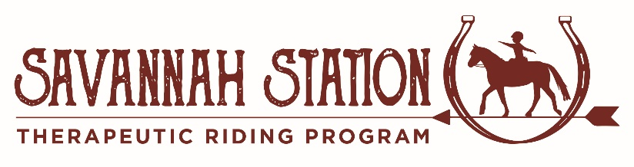
Savannah Station TRP
13420 Frisco Road
Yukon, OK 73099
580-303-2028
info@savannahstation.org

Volunteer Application

Minimum age to volunteer: 14
Please Print

Name: ______________________________________________________ Date: ____________________

Address: ______________________________________________________________________________

City: __________________________________________________ State: _________ Zip: ____________

Cell: _____________________________ Email: ______________________________________________

DOB: ________________________ Employer/School: _________________________________________

CPR/First Aid Certification: Yes No If yes, please attach copy of certification.

If Minor – Parent/Legal Guardian Name: ____________________________________________________

Cell: _____________________________ Email: ______________________________________________

How did you learn about Savannah Station? _________________________________________________

Relevant Education, Training, Skills, Hobbies, and/or Experiences: _______________________________

_____________________________________________________________________________________

_____________________________________________________________________________________

Day(s) Available: ____________________________________ Morning Afternoon Evening

Areas of Interest: Feed Team Horse Leader Sidewalker Grounds Special Events

Volunteer Recruitment Fundraising Board Marketing Grant Writing Photography

Social Media Office Work

Other: _______________________________________________________________________________

Health History: Please describe your current health status, particularly regarding the physical/emotional demand of working in an equine-assisted program. Address fitness, stamina, cardiac, respiratory, bone or joint function, recent hospitalizations/surgeries or lifestyle changes.

_____________________________________________________________________________________

_____________________________________________________________________________________

Allergies: _____________________________________________________________________________

Medications: __________________________________________________________________________

Recent Medical Tests: ________ Last Tetanus Shot: _________ Tuberculosis Test: + - Date: _________

Emergency Contact: (PATH Standard A11)

Name: __________________________ Relationship: __________________ Cell: ___________________

I understand that the information provided above is accurate to the best of my knowledge. I know of no reason why I should not participate as a volunteer in the Savannah Station Therapeutic Riding Program.

Signature: _________________________________________________ Date: ______________________

Background Information:

Have you ever been charged with or convicted of a crime? Yes No

If yes, please explain: ___________________________________________________________________

I, ________________________________________, authorize Savannah Station Therapeutic Riding Program to receive information from any law enforcement agency, including police departments and sheriff’s departments, of this state or any other state or federal government, to the extent permitted by state and federal law, pertaining to any convictions I may have had for violations of state or federal criminal laws, including but not limited to convictions for crimes committed upon children or animals.

I understand that such access is for the purpose of considering my application as a volunteer, and I expressly DO NOT authorize Savannah Station Therapeutic Riding Program, its directors, officers, employees, or other volunteers to disseminate this information in any way to any other individual, group, agency, organization or corporation.

Signature: ________________________________________________ Date: _______________________

Social Security #: ___________________________________________DOB: ______________________

There is a $10 fee for Background Checks. Please make checks payable to Savannah Station TRP.

Liability Release

I acknowledge the risks and potential for risks of working with and or being around horses/horseback riding. I hereby, intending to be legally bound, for myself, my heirs and assigns, executors, or administrators, waive and release forever all claims for damages against Savannah Station Therapeutic Riding Program, their Board of Directors, Instructors, Therapists, Aides, Volunteers and/or Employees for any and all injuries and/or losses that I/my child/my ward may sustain while participating with the Savannah Station Therapeutic Riding Program.

Signature: ____________________________________________ Date: __________________
(PATH Standard A14)

Confidentiality Agreement

I understand that all information, written and verbal, about participants at Savannah Station Therapeutic Riding Program is confidential and will not be shared with anyone without the express written consent of the participant and their parent/guardian in the case of a minor.

Signature: ____________________________________________ Date: __________________
(PATH Standard A22)

Photo Release

I DO / DO NOT consent to and authorize the use and reproduction by Savannah Station Therapeutic Riding Program of any and all photographs and any other audio/visual materials taken of me, my minor child or my ward for promotional purposes, educational activities, exhibitions or for any other use for the benefit of the program.

Signature: ____________________________________________ Date: __________________
(PATH Standard A15)

